**NOTICE OF SEALED BID AUCTION**  
**Town of Gate City – Decorative Streetlight Auction**

The Town of Gate City is accepting sealed bids for the purchase of vintage decorative streetlights that have recently been removed from the downtown business district. These five-globe, Victorian-style lights have lined the streets of Gate City for decades and are now being made available to the public through a sealed bid process.

A total of 15 lights are available. Each light is approximately 10 feet, 3 inches tall with a 15-½ inch diameter base. The lights are at least 30 years old and are being sold as-is, with no warranty expressed or implied. Interested parties are strongly encouraged to inspect the lights prior to bidding. Appointments for inspection can be made by contacting the Gate City Town Office at (276) 386-3831.

All sales are final. The Town makes no representation as to the operability or condition of the lights. Cleaning, repair, or restoration may be required.

Bids must be submitted using the official bid form below and received no later than 2:00 PM on April 30, 2025. Email bids will not be accepted. Bids received after the deadline will not be considered.

Sealed bids should be mailed or delivered to:  
Town of Gate City  
Attn: Sealed Bid – Streetlights  
156 East Jackson Street  
Gate City, VA 24251

**The Gate City Town Council reserves the right to reject any and all bids.**

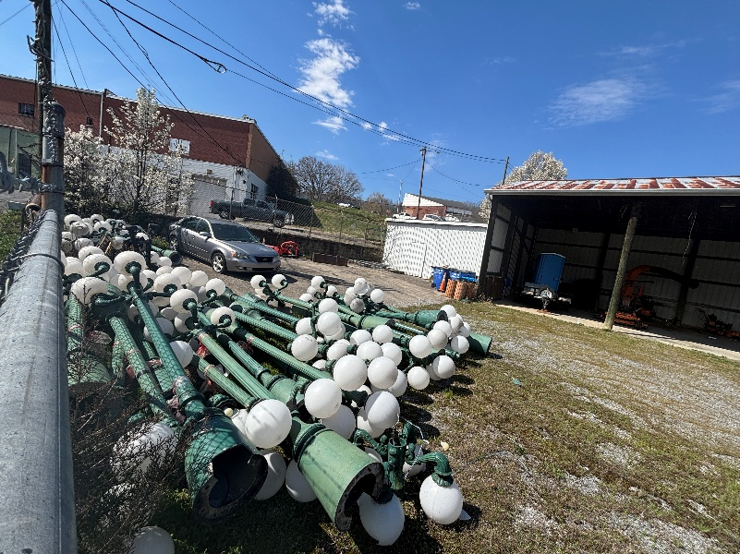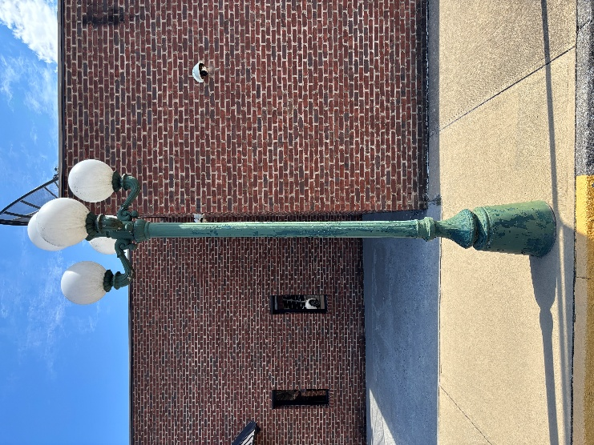

**SEALED BID FORM**  
**Town of Gate City – Decorative Streetlight Auction**

**Name:** ____________________________________________

**Mailing Address:** ____________________________________

**Phone Number:** ______________________________________

**Email Address:** _______________________________________

**Number of Lights Requested:** _____________________________

**Bid Amount Per Light:** $______**.**

**Total Bid Amount (Bid per Light x Number of Lights):** $______**.**

By signing below, I acknowledge and agree to the following:

* I understand the streetlights are at least 30 years old and are sold as-is with no warranty.
* I understand that all sales are final, and the Town makes no guarantee of operability or condition.
* I understand that email bids will not be accepted, and bids must be sealed and received by 2:00 PM on May 30, 2025.
* I understand that I may inspect the lights by appointment prior to the bid deadline.
* I understand that the Gate City Town Council reserves the right to reject any and all bids.

**Signature:** ___________________________________  
  
  
**Date:** _______________________________________